GET DATA
/TYPE=XLSX
/FILE='C:\Users\efilguer\Downloads\Soccer Data.xlsx'
/SHEET=name 'Soccer_FullData'
/CELLRANGE=FULL
/READNAMES=ON
/DATATYPEMIN PERCENTAGE=95.0
/HIDDEN IGNORE=YES.
EXECUTE.
DATASET NAME DataSet1 WINDOW=FRONT.
GRAPH
/SCATTERPLOT(BIVAR)=Shot_Power WITH Attacking_Position
/MISSING=LISTWISE.

Graph

Notes
Output Created |  | 14-FEB-2019 15:13:35
Comments
Input | Active Dataset | DataSet1
Input | Filter | <none>
Input | Weight | <none>
Input | Split File | <none>
Input | N of Rows in Working Data File | 17588
Syntax |  | GRAPH  /SCATTERPLOT(BIVAR)=Shot_Power WITH Attacking_Position  /MISSING=LISTWISE.
Resources | Processor Time | 00:00:01.37
Resources | Elapsed Time | 00:00:01.57

[DataSet1]

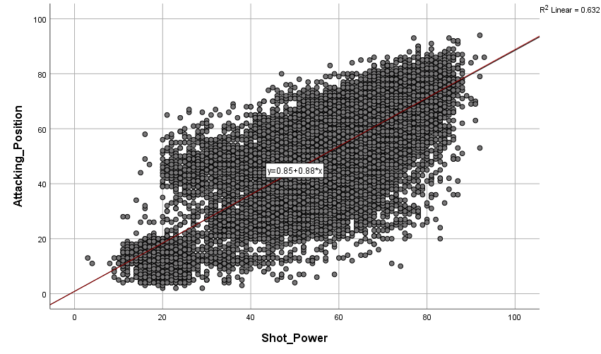

CORRELATIONS
/VARIABLES=Attacking_Position Shot_Power
/PRINT=TWOTAIL NOSIG
/MISSING=PAIRWISE.

Correlations

Notes
Output Created |  | 14-FEB-2019 15:15:28
Comments
Input | Active Dataset | DataSet1
Input | Filter | <none>
Input | Weight | <none>
Input | Split File | <none>
Input | N of Rows in Working Data File | 17588
Missing Value Handling | Definition of Missing | User-defined missing values are treated as missing.
Missing Value Handling | Cases Used | Statistics for each pair of variables are based on all the cases with valid data for that pair.
Syntax |  | CORRELATIONS  /VARIABLES=Attacking_Position Shot_Power  /PRINT=TWOTAIL NOSIG  /MISSING=PAIRWISE.
Resources | Processor Time | 00:00:00.05
Resources | Elapsed Time | 00:00:00.13

Correlations
 |  | Attacking_Position | Shot_Power
Attacking_Position | Pearson Correlation | 1 | .795**
Attacking_Position | Sig. (2-tailed) |  | .000
Attacking_Position | N | 17588 | 17588
Shot_Power | Pearson Correlation | .795** | 1
Shot_Power | Sig. (2-tailed) | .000
Shot_Power | N | 17588 | 17588

**. Correlation is significant at the 0.01 level (2-tailed).

Notes
Output Created |  | 14-FEB-2019 15:16:34
Comments
Input | Active Dataset | DataSet1
Input | Filter | <none>
Input | Weight | <none>
Input | Split File | <none>
Input | N of Rows in Working Data File | 17588
Missing Value Handling | Definition of Missing | User-defined missing values are treated as missing.
Missing Value Handling | Cases Used | Statistics are based on cases with no missing values for any variable used.
Syntax |  | REGRESSION  /MISSING LISTWISE  /STATISTICS COEFF OUTS R ANOVA  /CRITERIA=PIN(.05) POUT(.10)  /NOORIGIN  /DEPENDENT Attacking_Position  /METHOD=ENTER Shot_Power.
Resources | Processor Time | 00:00:00.05
Resources | Elapsed Time | 00:00:00.09
Resources | Memory Required | 5008 bytes
Resources | Additional Memory Required for Residual Plots | 0 bytes

REGRESSION
/DESCRIPTIVES MEAN STDDEV CORR SIG N
/MISSING LISTWISE
/STATISTICS COEFF OUTS R ANOVA
/CRITERIA=PIN(.05) POUT(.10)
/NOORIGIN
/DEPENDENT Attacking_Position
/METHOD=ENTER Shot_Power
/SAVE ZRESID.

Regression

Notes
Output Created |  | 14-FEB-2019 15:18:06
Comments
Input | Active Dataset | DataSet1
Input | Filter | <none>
Input | Weight | <none>
Input | Split File | <none>
Input | N of Rows in Working Data File | 17588
Missing Value Handling | Definition of Missing | User-defined missing values are treated as missing.
Missing Value Handling | Cases Used | Statistics are based on cases with no missing values for any variable used.
Syntax |  | REGRESSION  /DESCRIPTIVES MEAN STDDEV CORR SIG N  /MISSING LISTWISE  /STATISTICS COEFF OUTS R ANOVA  /CRITERIA=PIN(.05) POUT(.10)  /NOORIGIN  /DEPENDENT Attacking_Position  /METHOD=ENTER Shot_Power  /SAVE ZRESID.
Resources | Processor Time | 00:00:00.03
Resources | Elapsed Time | 00:00:00.08
Resources | Memory Required | 5008 bytes
Resources | Additional Memory Required for Residual Plots | 0 bytes
Variables Created or Modified | ZRE_1 | Standardized Residual

Descriptive Statistics
 | Mean | Std. Deviation | N
Attacking_Position | 49.59 | 19.407 | 17588
Shot_Power | 55.58 | 17.600 | 17588

Correlations
 |  | Attacking_Position | Shot_Power
Pearson Correlation | Attacking_Position | 1.000 | .795
Pearson Correlation | Shot_Power | .795 | 1.000
Sig. (1-tailed) | Attacking_Position | . | .000
Sig. (1-tailed) | Shot_Power | .000 | .
N | Attacking_Position | 17588 | 17588
N | Shot_Power | 17588 | 17588

Variables Entered/Removedª
Model | Variables Entered | Variables Removed | Method
1 | Shot_Power^{b} | . | Enter

a. Dependent Variable: Attacking_Position
b. All requested variables entered.

Model Summary^{b}
Model | R | R Square | Adjusted R Square | Std. Error of the Estimate
1 | .795ª | .632 | .632 | 11.766

a. Predictors: (Constant), Shot_Power
b. Dependent Variable: Attacking_Position

ANOVAª
Model |  | Sum of Squares | df | Mean Square | F | Sig.
1 | Regression | 4189283.444 | 1 | 4189283.444 | 30260.759 | .000^{b}
1 | Residual | 2434596.524 | 17586 | 138.439
1 | Total | 6623879.969 | 17587

a. Dependent Variable: Attacking_Position
b. Predictors: (Constant), Shot_Power

Coefficientsª
Model |  | Unstandardized Coefficients |  | Standardized Coefficients | t | Sig.
 |  | B | Std. Error | Beta | t | Sig.
1 | (Constant) | .852 | .294 |  | 2.899 | .004
1 | Shot_Power | .877 | .005 | .795 | 173.956 | .000

a. Dependent Variable: Attacking_Position

Residuals Statisticsª
 | Minimum | Maximum | Mean | Std. Deviation | N
Predicted Value | 3.48 | 82.41 | 49.59 | 15.434 | 17588
Residual | -55.744 | 45.733 | .000 | 11.766 | 17588
Std. Predicted Value | -2.988 | 2.126 | .000 | 1.000 | 17588
Std. Residual | -4.738 | 3.887 | .000 | 1.000 | 17588

a. Dependent Variable: Attacking_Position

GRAPH
/SCATTERPLOT(BIVAR)=Shot_Power WITH ZRE_1
/MISSING=LISTWISE.

Graph

Notes
Output Created |  | 14-FEB-2019 15:18:22
Comments
Input | Active Dataset | DataSet1
Input | Filter | <none>
Input | Weight | <none>
Input | Split File | <none>
Input | N of Rows in Working Data File | 17588
Syntax |  | GRAPH  /SCATTERPLOT(BIVAR)=Shot_Power WITH ZRE_1  /MISSING=LISTWISE.
Resources | Processor Time | 00:00:00.83
Resources | Elapsed Time | 00:00:00.83

